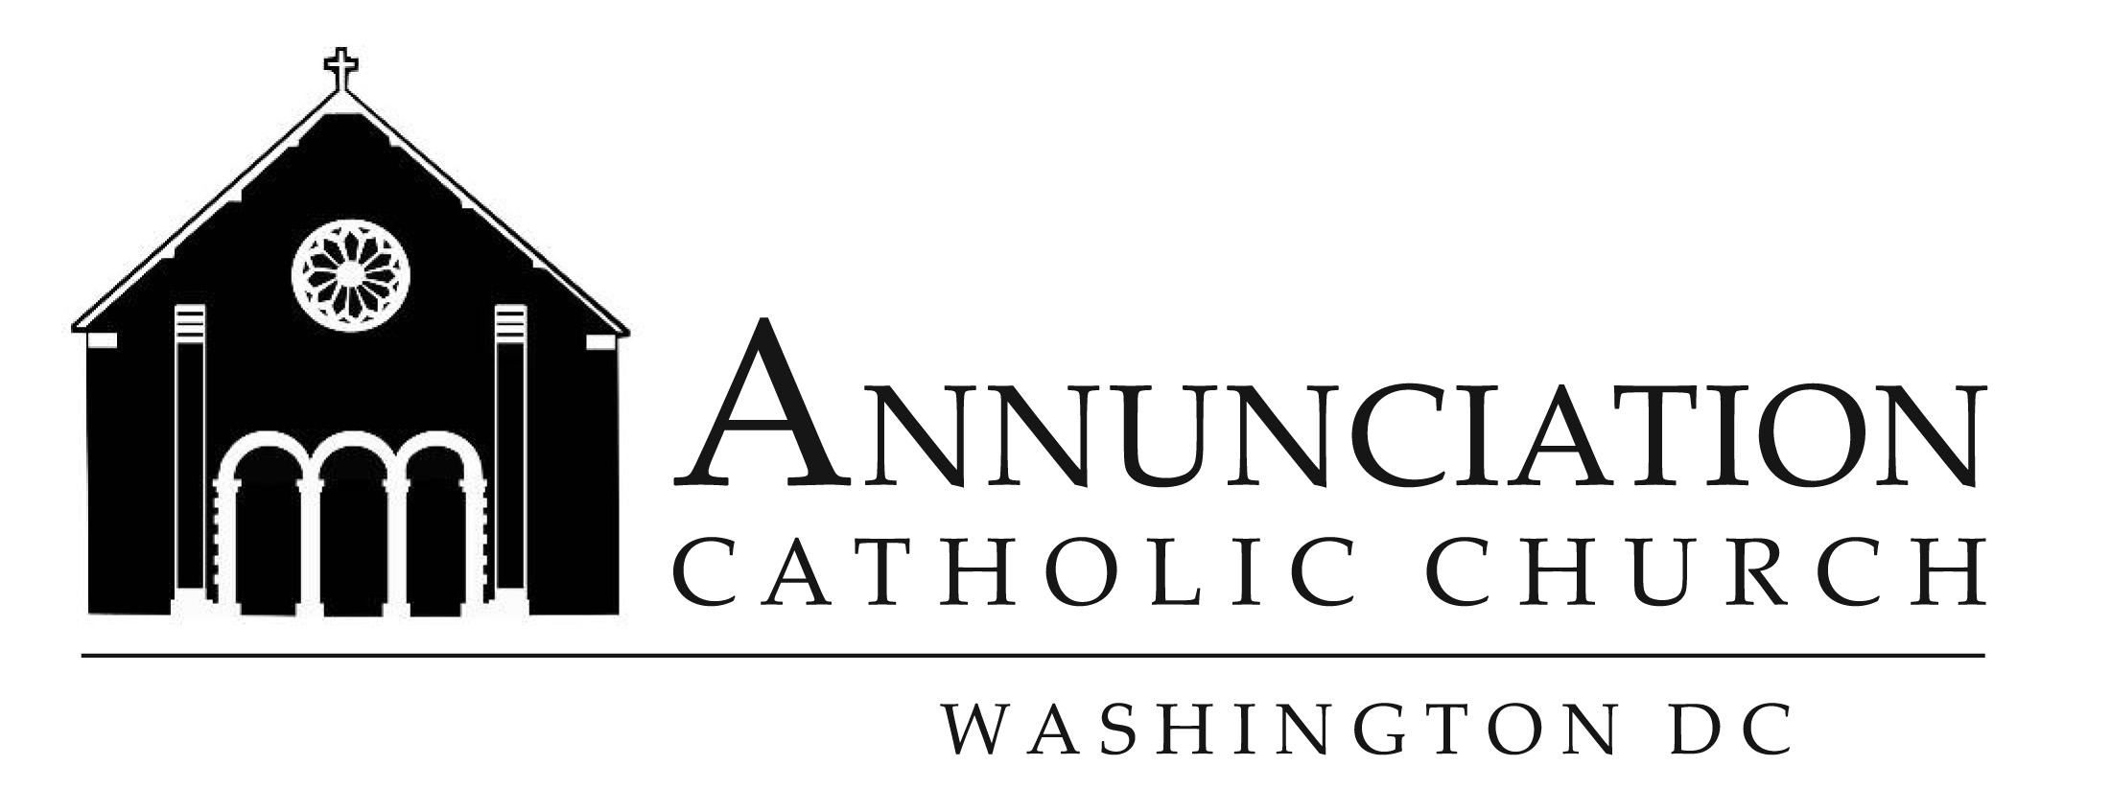
Adult Faith Formation
Meets in Parish Center
Wednesdays 7pm to 8:15pm
Catholicism Series By Bishop Barron
September 19 Lesson 1 Part 1
September 26 Lesson 1 Part 2 *Meeting held at Parish Conference Room
October 3 Lesson 2 Part 1
October 10 Lesson 2 Part 2
October 17 Lesson 3 Part 1
October 24 Lesson 3 Part 2
November 7 Lesson 4 Part 1
November 14 Lesson 4 Part 2 * Meeting held in Church
November 28 Lesson 5 Part 1
December 5 Lesson 5 Part 2
December 12 Lesson 6 Part 1
December 19 Lesson 6 Part 2
January 9 Lesson 7 Part 1
January 16 Lesson 7 Part 2
January 23 Lesson 8 Part 1
January 30 Lesson 8 Part 2
February 6 Lesson 9 Part 1
February 13 Lesson 9 Part 2
February 20 Lesson 10 Part 1
February 27 Lesson 10 Part 2
March 13 The Mass
March 20 The Mass
March 27 The Mass
April 3 The Mass
April 10 The Mass
May 1 The Mass

